# California State University, Fresno

# DEPARTMENT OF COMPUTER SCIENCE

|  |  |  |  |  |  |
| --- | --- | --- | --- | --- | --- |
| Class: | **Algorithms & Data Structures** | | | Semester: | **Spring 2022** |
|  | | | | | |
| Points |  | Document author: | **MingkuanPang** | | |
|  | Author’s email: | **Yafking20 @mail.fresnostate.edu. email** | | |
| Laboratory number: | **06 - Quick Sort** | | |
|  | | | | | |

**1. Statement of Objectives**

This lab asks for implementation of quick sort in three ways: The first element be pivot, a random element in the array and the median of the first, middle, and last elements in the array to be pivot.

Finally, analyze and discuss the execution of time complexity for these three ways of implementation.

**2. Experimental Procedure**

**Partition:**

The partition function sets one of the elements in the array to be pivot, then divides the array into three parts: A [low…. pivot - 1], A [pivot], A [pivot + 1…. high]. The first part will be the set of all the numbers in the array that less than the pivot, the second part will be the pivot itself. The third part will be all the numbers in the array that greater than the pivot. First, makes pivot to be A[low]:

pivot = A [low], and the set the starting position of the larger number to high + 1: i = high+1. Then start scanning the whole array from the end. Every time if there is an element that greater than the pivot, decrease k by 1 than swap the element and the position of the higher number. After going through the whole array, the array will be

A [low…i…high]. A [low…i-1] will be the sub-array that has all the elements smaller than the pivot, and A [i... high] will be the sub-array that has all the elements greater than the pivot. Eventually, swap the pivot with i-1, then the array will be A [low…. pivot], A [i…. high]. That is A [low…. pivot-1], A[pivot], A [pivot+1…high] where pivot = i-1. It return the position of the pivot as a result.

**Quick sort:**

In the quick sort function, put the array into partition function that mentioned above first. Then it will be A [low … pivot - 1], A [pivot], A [pivot+1 … high]. Then do the same thing on those sub array A [low … pivot - 1], A [pivot+1 … high]. When the whole array is sorted, low will meet high. Which will be low=high. Therefore, when low is still less than high (low<high). We keep doing those operations on the array until low = high.

**Create_vector:**

It reads a list of numbers that separate by space and push them in to an array one by one. Finally, return the array as a result.

**Print_vector:**

It prints out the element of an array.

**Pick_median**

Pick_median will return the median number of three integers. First, calculates the average of those three integers than calculate the absolute difference of those integers with the average. Whoever is the closest one to the average will be the median number.

**Median_partition**

Median partition gets the median of the first, middle and last element in the array, then swap it to the element on the index “low”. Then pass the array to the regular partition function.

**Median quick sort**

Almost the same as the regular version of quick sort, but median quick sort uses median partition.

**Random_partition**

Random partition makes a random number “i” between low and high, then swap the element on the i and the element on the low. Eventually, pass the whole array to regular partition function.

**Random_quick_sort**

Random quick sort is almost the same as the regular quick sort, but it uses random_partition instead of the regular partition.

**3. Analysis**

**Main function:**

First, the program will ask you to choose which sorting algorithm you want to use, 1 for the regular quick sort, 2 for the random quick sort, 3 for the median quick sort, and 4 for testing the pick_median function. Enter letter ‘q’ to quit the choose. Then, after making choice, it will give results of those functions returns.

**Output**

**For testing function pick_median:**

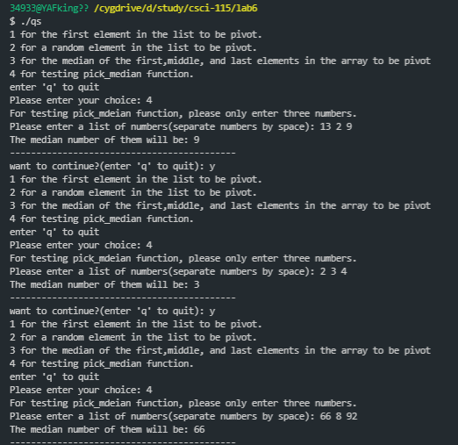

**For testing different types of quick sorts:**

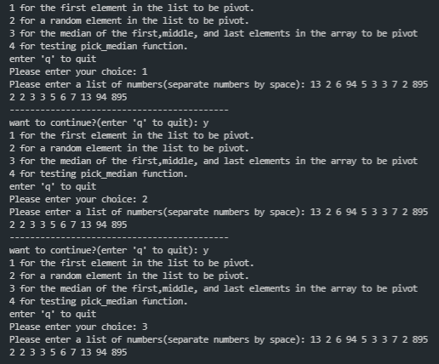

**4. Encountered Problems**

When implement the radix sorting, I try to use counting sort to help me sort the numbers on digits, but it did not go well. I can not figure out where I did wrong. Eventually I just give up using counting sort to help.

**5. Conclusions**

By the result of sorting array that has numbers from 0 to 999999999 in reverse order, we can see counting sort is much faster than the radix sort. The theoretical time complexity for counting sort is O(n+k) where k will be the range of the numbers and for radix sort it is n*log(r)m where r is the radix taken by, and m is the number of heaps. Obviously, in theory, counting sort is still faster than radix sort.

**6. References**

Chapter 8 counting sort and radix sort. *Introduction to algorithms third edition* – (Thomas H. Cormen, Charles E. Leiseron, Ronald L. Rivest, Clifford Stein)